1. Extensions off facebook events, Applications (meetup, eventbrite, foursquare etc..)
2. Maybe a physical solution: a communal board or area at like the student centre (but obviously more like refined and shit)
3. A mobile application
   1. Club finder
   2. Hobby finder
   3. course/program finder
   4. Threads, instead of “clubs” student drop threads of different topics. Or something. Maybe club idea is too intimidating. If we are trying to reach every student, they all have different hobbies and like not everyone would want to join a “club” so threads so more casual. Similar to slack but hobbies and such.
      1. Clubs may give off the idea of commitment
4. Integrate something into quercus
5. Could be like designated areas of school, for promoting group events. Each of these areas will have a hotspot and students can join in. (Libraries can have designated open study groups, soccer fields can have areas for pick-up games etc..)
   1. Only problem with this is, hobbies become selective?
6. A planner that would suggest what events are available during times that you are free - maybe built into acorn/quercus
7. Something that keeps tracks of all the social events you been to/ your friends been to - with a reward system or something
8. Something that will tell you if someone been to the same event as you, if you bump into them or something idk
9. Classic posters around the campus but more refined
   1. A more refined emailing system

So i think, personally. The 3 ideas we can sketch are 1 app, the community board one, and like quercus one.

* **An app (3) that combines point (d). So a “student” would implement their school schedule. The app finds events based off their schedule.**
  + **App is registered through school, so you can see what friends are going (quercus?)**

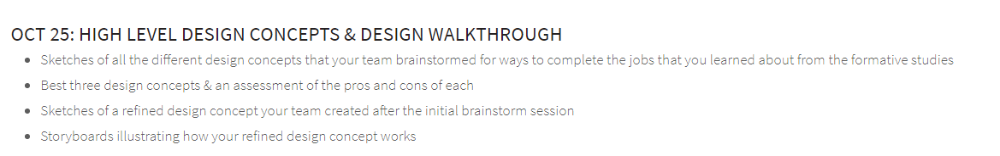

Notes:

**Reward system**

Super unordinary ideas

* An app like Timeplay but for 10 minute before class starts and stuff happens (cause people are busy)
* Some sort of bracelet, that shows you are looking for events

Solutions that the school can implement to help?

* An event page on school website

1. A tool that you put your schedule into and it suggests events that fit around deadlines & stuff
2. A more centralised list of all the shit going on at any point (like from emails & facebook & stuff) (possibly no1?)
3. An AI that pretends to be your friend so you’re less lonely (LOL)
4. A time management app for balancing work/leisure & planning when to do stuff around events - overlap with a

Ideas pat likes: + the Pascal seal of approval

* **An app (3) that combines point (d). So a “student” would implement their school schedule. The app finds events based off their schedule.**
  + **App is registered through school, so you can see what friends are going (quercus?)**

1. When I have a busy schedule and school work, I want to look for social events that fit into my schedule, so I can still have a balance between social life and academic life.
2. When I cannot find social events that fit my interests, I want to look on social media to see what events my friends are interested in, so I know what events are available and which friends I can go to the events with.
3. When I have anxiety attending social events by myself, I want to know which friends are attending certain events to ask friends to attend events with me, so I can have someone to go to the events with.
4. When I know I have assignments and midterms coming up, I want to know what events are available far in advance and finish my work early, so I do not have to stress when I attend the social event.
5. When I am looking to make friends at school and join more social events, I want to look into becoming a member of a student club the I am interested in, so I can follow up on the events hosted by that club and meet people that have the same interest as me.